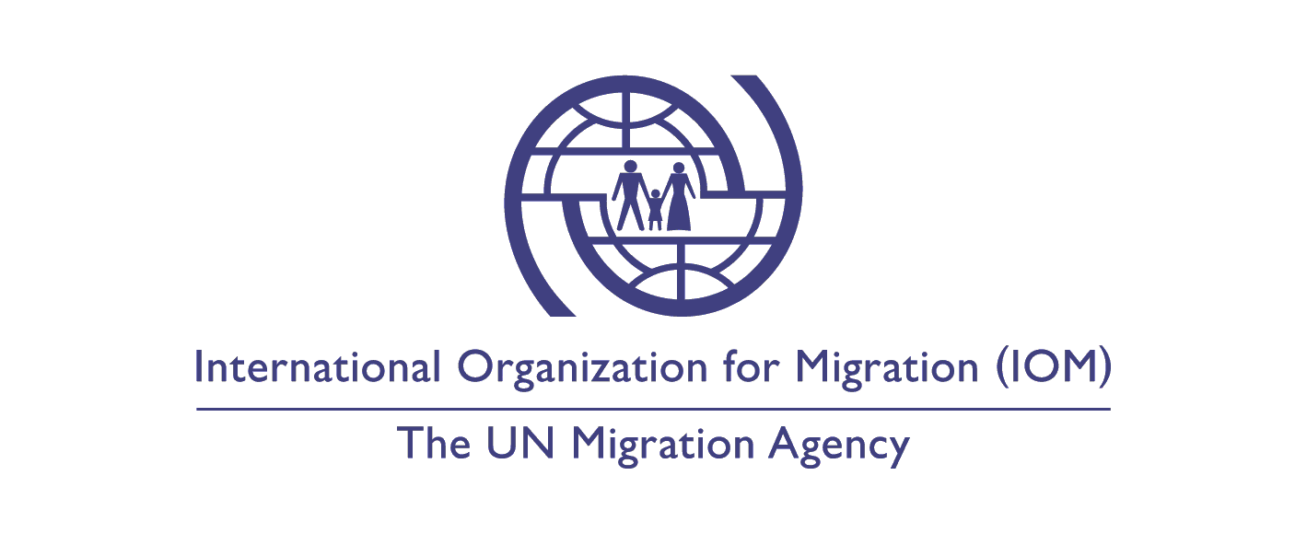
Position Title: Medical doctor

Duty Station: Temporary Transit Center Tabanovce, Kumanovo, the Republic of North Macedonia
Classification: Consultant, Grade OTHE
Type of Appointment: Hourly contract
Estimated Start Date: as soon as possible
Closing Date: 2 February 2020
Reference: CFA IOM-SKP-2020-07
Established in 1951, IOM is a Related Organization of the United Nations, and as the leading UN agency in the field of migration, works closely with governmental, intergovernmental and non-governmental partners. IOM is dedicated to promoting humane and orderly migration for the benefit of all. It does so by providing services and advice to governments and migrants.

Context:

The IOM Office in Skopje is looking for a medical doctor in the Temporary Transit Center (TTC) Tabanovce Kumanovo area within the project “Special Measure on supporting the Republic of North Macedonia to improve its border and migration management capabilities” funded by the European Union.
IOM Skopje, in close cooperation with the Ministry of Health, will be working to ensure the availability of medical services at the TTC Tabanovce in Kumanovo through supporting the work of medical teams based at the established primary health ambulances in the TTC. The work of the medical teams will be organized in 8-hour shifts, thus ensuring admission and treatment of migrants in line with human rights standards.

Each medical team will consist of one nurse and one doctor.

Core Functions / Responsibilities:

- Perform medical screening in TTC;
- Consult migrants, refugees and asylum seekers using services of Health Clinics;
- Prescribe medications as per National guidelines;
- Ensure referral of migrant patients requiring Emergency medical care in higher level medical institutions/facilities;
- Provide regular reports related to Health clinic activities: weekly, monthly and quarterly;
- Maintain the medical documentation of medically screened cases and ensure confidentiality of registered information;
- Contact specialists regarding different medical follow-up on migrant’s examinations;
- Perform fit-to-travel screening activities of migrants prior to departure;
- Liaise with local Health Authorities and medical entities related with above mentioned activities;
- Perform any other tasks that may be assigned by the Head of Office/Health Program Officer or IOM Skopje designated staff.

Tangible and measurable outputs of the work assignment:
• Weekly, monthly and quarterly reports related to Health clinic activities provided;

Performance indicators for evaluation of results:
- Satisfactory completion of tasks indicated in this ToR;

Required Qualifications and Experience:

Education
Medical Doctor Degree from an accredited academic institution;

Experience
- Previous experience of minimum 3 years in this profession;
- Previous work with migrants, refugees, asylum seekers - is an advantage
- Experience working in/with institutions, NGO/IGO environments;

Technical
- Valid Medical Licence

Languages

Good knowledge of Macedonian and English.

Note
The consultant must adhere to the International Organization for Migration (IOM) Data Protection Principles (IN/138) and maintain confidentiality (IN/165).

Application procedure:
Interested candidates are invited to send CV in English via email to recruitmentskopje@iom.int indicating the position title and reference code in the email and subject line.

Applications from qualified female candidates are highly encouraged.

Only shortlisted candidates will be contacted.

Desirable Competencies:

Values
- Inclusion and respect for diversity: respects and promotes individual and cultural differences; encourages diversity and inclusion wherever possible.
- Integrity and transparency: maintain high ethical standards and acts in a manner consistent with organizational principles/rules and standards of conduct.
- Professionalism: demonstrates ability to work in a composed, competent and committed manner and exercises careful judgment in meeting day-to-day challenges.
Core Competencies – behavioral indicators
- Teamwork: develops and promotes effective collaboration within and across units to achieve shared goals and optimize results.
- Delivering results: produces and delivers quality results in a service-oriented and timely manner; is action oriented and committed to achieving agreed outcomes.
- Managing and sharing knowledge: continuously seeks to learn, share knowledge and innovate.
- Accountability: takes ownership for achieving the Organization’s priorities and assumes responsibility for own action and delegated work.
- Communication: encourages and contributes to clear and open communication; explains complex matters in an informative, inspiring and motivational way.

Other:
- The appointment is subject to funding confirmation.
- No late applications will be accepted.

How to apply:

The Vacancy is open for external candidates that have the legal right to reside and work in the Republic of North Macedonia.

We invite all interested candidates to submit their CV in English via email to recruitmentskopje@iom.int quoting the position title and reference number in the subject.

Posting period:
From 29.01.2020 to 02.02.2020

